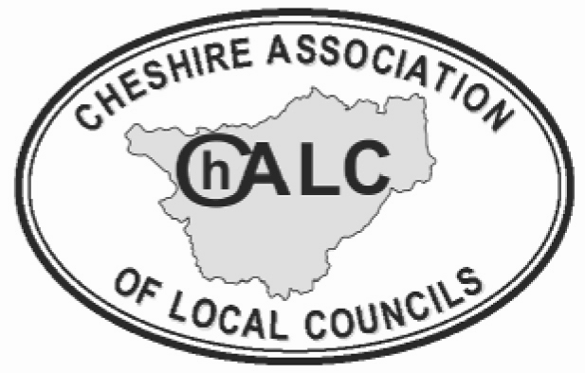

ChALC Board Membership
Application Form - 2025

Name:

Council:
Experience:

Skills or knowledge that you bring to the Board:

Continue overleaf if necessary

Please return your completed form by
Friday 3rd October 2025

Cheshire Association of Local Councils, Park View Business Centre, Combermere, Whitchurch, Shropshire, SY13 4AL
email: jackieweaver@chalc.org.uk

