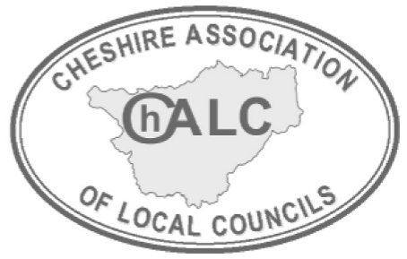
ChALC ANNUAL MEETING 2025

MOTION SUBMISSION FORM

The Annual Meeting provides an opportunity for representatives from member councils to discuss and canvass support on issues that are important to them. If your Council would like to submit a motion for discussion, please read the guidance below and complete the form for submission by 4th July 2025

GUIDANCE NOTES
- At a basic level, a motion should have a title and a formal instruction or action for the ChALC to carry out, for example, ‘This meeting calls upon the Cheshire Association of Local Councils to lobby/write/review’. It should not simply state a position – for example ‘This meeting deplores/notes/agrees/disagrees with the statement …’.
- It is also important to have explanatory text covering what the issue is and why it should be important to the Annual Meeting. The topic of the motion is however open to the Council to decide.
- The attached motion form therefore has separate sections for: -
  - Additional Information – providing details about concerns and any background
  - The Action sought – the formal instructions to the meeting
- Where motions are borough specific, ChALC will as a matter of course apply them to the ChALC sub-region if appropriate.

Any Member Council wishing to put forward a motion to the Annual Meeting should ensure that: -
  - They provide details of their council meeting where the motion was discussed and resolved
  - They have paid their 2025.26 affiliation fee by 1st July 2025
  - They will have someone present and willing to put the motion to the meeting, and a further person to second the motion.

Process of handling Motions
- Motions may be submitted on the attached form at any time from 1st April up to the first week in July each year, for consideration at that year’s Annual Meeting in October.
- All motions submitted will be subject to a triage process to ensure they meet basic requirements of clarity, relevance and purpose. ChALC will aim to confirm within 3 weeks of receipt of submission.
- If necessary, a motion may be returned to a council for recommended changes as part of feedback and will need to comply with the deadline date for return.

ChALC ANNUAL MEETING 2025 – MOTION Deadlines

TASK | DEADLINE DATE
Final deadline for Motions to be submitted for triage | Friday 4th July 2025
Final deadline for ChALC to provide feedback to Councils | Friday 25th July 2025
Final deadline for councils to respond | Friday 15th August 2025
FINAL Motions to Executive Board | 10th September 2025
ANNUAL MEETING | 16th October 2025

MOTION TO ChALC ANNUAL MEETING 2025

NAME OF PARISH/TOWN COUNCIL: …………………………………………………..

TITLE OF PROPOSED MOTION: ………………………………………………………….

ADDITIONAL INFORMATION (What are your concerns and why is action necessary? Please provide details and any background – you may attach a separate sheet if required)

Cont/.

FORMAL REQUEST FOR ACTION – This meeting calls upon the Cheshire Association of Local Councils to: -

Name of Proposer………………………………………………….

Name of Seconder …………………………………………………

Date of Council Meeting where Motion was resolved & minuted ………………………………

Signed on behalf of the Council……………………………………………………… Clerk/Chairman

Date: ………………………………

ChALC OFFICE USE ONLY:

DATE RECEIVED INTO OFFICE

REVIEWED - Any further work required? | YES NO Initials of reviewer
DATE ANY TRIAGE RESPONSE SENT TO COUNCIL

DATE COUNCIL RESPONDED

Comment(s):

