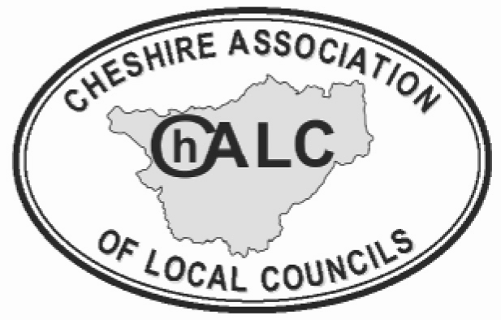
ON-SITE TRAINING SESSION
EXPRESSION OF INTEREST FORM

COUNCIL NAME ………………………………………………………………………………

TRAINING REQUIRED ………………………………………………………………………………
If you are considering asking ChALC to deliver a customised training session for your Town/Parish Council, there are several points to take into account before booking.

Please complete the questions below and return the completed form to sharon.angus-crawshaw@chalc.org.uk or nikkiroberts@chalc.org.uk
 |  | Response
Date | Please allow 8 weeks notice for scheduling.
Time | Training sessions are usually delivered in the afternoon or evening. We suggest start times of 2 pm or 6.30 pm.  Full days can be arranged with suggested start time of 9.30 and finishing at 4.30.
Numbers | For locally delivered sessions you must have a minimum of 15 people attending, if the numbers drop below 15 we will still charge for 15 places
Venue | Where will the training be delivered? We require a room that will accommodate delegates working around tables in small groups.
Equipment | Do you have a projector and screen? If not please advise accordingly.
Refreshments | Can you provide tea/coffee and biscuits for people on arrival and mid-session break?  Full-day sessions will also require arrangements to be made for lunch.
Cost | ChALC Members: £22.50 per person or £45 pp for a full day (N.B. see note re numbers above)
Content | Please state any specific matters you wish to address in the training session.

