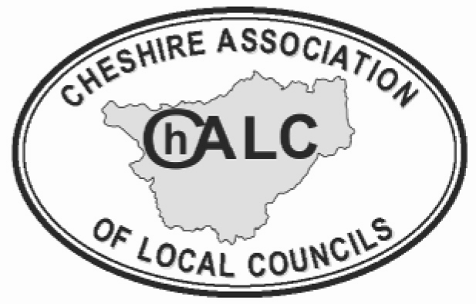
VIRTUAL TRAINING SESSION
EXPRESSION OF INTEREST FORM

COUNCIL NAME ………………………………………………………………………………

TRAINING REQUIRED ………………………………………………………………………………
Before asking ChALC to deliver a customised training session for your Town/Parish Council, there are several points to consider before booking.
Please complete the questions below and return the completed form to
sharonangus-crawshaw@chalc.org.uk or nikkiroberts@chalc.org.uk
 |  | Response
Date | Please allow 6 weeks notice for scheduling.
Time | Training sessions are usually delivered in the afternoon or evening – 2 hours maximum. We suggest start times of either 2 pm or 6.30 pm.
Numbers and Cost | Please note Virtual Sessions are offered to ChALC Members at a minimum charge of £150 which equates to up to 10 participants at £15.00 per person. Additional participants above this number will be charged for at £15.00 per person. The maximum number per session is 20 people
Content | Please state any specific matters you wish to address in the training session.

