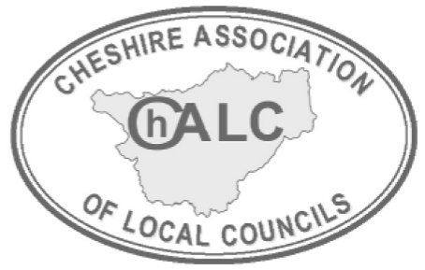

ChALC ANNUAL MEETING 2024

MOTION SUBMISSION FORM

The Annual Meeting provides an opportunity for members to discuss and canvass support on issues that are important to them. If your Council would like to submit a motion for discussion, please read the guidance below and complete the form for submission by the specified date.

GUIDANCE NOTES

- At a basic level, a motion should have a title and a formal instruction or action for the Association to carry out, for example, ‘This meeting calls upon the Cheshire Association of Local Councils to lobby/write/review’. It should not simply state a position – for example ‘This meeting deplores/notes/agrees/disagrees with the statement …’.
- It is also important to have explanatory text covering what the issue is and why it is important to the Annual Meeting. The topic of the motion is however open to the Council to decide.
- The attached motion form therefore has separate sections for: -
  - Additional Information – providing details about concerns and any background
  - The Action sought – the formal instructions to the meeting
- Any Member Council wishing to put a motion to the Annual Meeting should ensure that there will be someone present and willing to put the motion to the meeting and a further person to second the motion.

Process of handling Motions
- Motions may be submitted on the attached form at any time from 1st January up to the first week in July each year, for consideration at that year’s Annual Meeting in October.
- All motions submitted will be subject to a triage process to ensure they meet basic requirements of clarity, relevance and purpose. ChALC will aim to confirm within 3 weeks of receipt of submission.
- If necessary, a motion may be returned to a council for recommended changes as part of feedback and will need to comply with the deadline date for return.
- Please refer to table below for details of tasks and final deadline dates

ChALC ANNUAL MEETING 2024 – MOTION Deadlines

TASK | DEADLINE DATE
Final deadline for Motions to be submitted for triage | Friday 5th July 2024
Final deadline for ChALC to provide feedback to Councils | Friday 26th July 2024
Final deadline for councils to respond | Friday 16th August 2024
FINAL Motions to Executive Board | 11th September 2024
ANNUAL MEETING | 17th October 2024

MOTION TO ChALC ANNUAL MEETING 2024

NAME OF PARISH/TOWN COUNCIL: …………………………………………………..

TITLE OF PROPOSED MOTION: ………………………………………………………….

ADDITIONAL INFORMATION (What are your concerns and why is action necessary? Please provide details and any background – you may attach a separate sheet if required)

Cont/.

FORMAL REQUEST FOR ACTION – This meeting calls upon the Cheshire Association of Local Councils to: -

Name of Proposer………………………………………………….

Name of Seconder …………………………………………………

Signed on behalf of the Council……………………………………………………… Clerk/Chairman

Date: ………………………………

ChALC OFFICE USE ONLY:

DATE RECEIVED INTO OFFICE

REVIEWED - Any further work required? | YES NO Initials of reviewer
DATE ANY TRIAGE RESPONSE SENT TO COUNCIL

DATE COUNCIL RESPONDED

Comment(s):

